Problem 1: Simulation and Analysis of 16-QAM Modulation in 5G NR
Implement and analyze a 16-QAM modulation scheme for 5G NR systems. Evaluate the Bit Error Rate (BER) performance over an AWGN channel and plot BER versus SNR.
- Develop a MATLAB/Octave simulation of 16-QAM modulation and demodulation.
- Transmit data through an AWGN channel.
- Analyze BER performance as a function of SNR.

Program:
clc;
clear;
close all;

% Parameters
M = 64; % Modulation order (4, 16, 64)
k = log2(M); % Bits per symbol
num_bits = 1000; % Total number of bits

% Generate random bits
bits = randi([0 1], num_bits, 1);

% Ensure length of bits is a multiple of k
num_symbols = floor(length(bits) / k);
bits = bits(1:num_symbols * k);

% Reshape bits into k-bit groups (each row = 1 symbol)
bit_groups = reshape(bits, k, num_symbols).';

% Manual binary to decimal conversion (replace bi2de)
powers_of_two = 2.^(k-1:-1:0);
symbol_indices = bit_groups * powers_of_two.'; % decimal symbol indices

% Generate QAM constellation points (square QAM only)
m_sqrt = sqrt(M);
if mod(m_sqrt, 1) ~= 0
error('M must be a perfect square for square QAM');
end

% Create I and Q points
I = -(m_sqrt - 1):2:(m_sqrt - 1);
Q = -(m_sqrt - 1):2:(m_sqrt - 1);

% Create meshgrid and flatten it
[II, QQ] = meshgrid(I, Q);
constellation = II(:) + 1j * QQ(:);

% Normalize constellation power to 1
constellation = constellation / sqrt(mean(abs(constellation).^2));

% Modulate: map indices to constellation points
tx_symbols = constellation(symbol_indices + 1);

% Plot transmitted symbols (Constellation Diagram)
figure;
scatter(real(tx_symbols), imag(tx_symbols), 'filled');
xlabel('In-Phase');
ylabel('Quadrature');
title([num2str(M) '-QAM Constellation (Transmitted Symbols)']);
grid on;

% Add AWGN Noise (Optional)
snr_db = 20; % SNR in dB
snr_linear = 10^(snr_db/10);
noise_variance = 1 / (2 * snr_linear);
noise = sqrt(noise_variance) * (randn(size(tx_symbols)) + 1j * randn(size(tx_symbols)));

rx_symbols = tx_symbols + noise;

% Demodulate: Find nearest constellation point
distances = abs(rx_symbols - constellation.');
[~, demod_indices] = min(distances, [], 2);

% Manual decimal to binary conversion (replace de2bi)
demod_bits = zeros(num_symbols, k);
for i = 1:k
demod_bits(:, i) = bitget(demod_indices - 1, k - i + 1);
end

% Reshape to column vector
demod_bits = reshape(demod_bits.', [], 1);

% Compute BER (Bit Error Rate)
num_errors = sum(bits ~= demod_bits);
ber = num_errors / length(bits);

% Display results
disp(['Number of bit errors: ' num2str(num_errors)]);
disp(['Bit Error Rate (BER): ' num2str(ber)]);

% Plot received symbols (With noise)
figure;
scatter(real(rx_symbols), imag(rx_symbols), 'filled');
xlabel('In-Phase');
ylabel('Quadrature');
title([num2str(M) '-QAM Constellation (Received Symbols with Noise, SNR = ' num2str(snr_db) ' dB)']);
grid on;

Results:
M=4
Number of bit errors: 0
Bit Error Rate (BER): 0

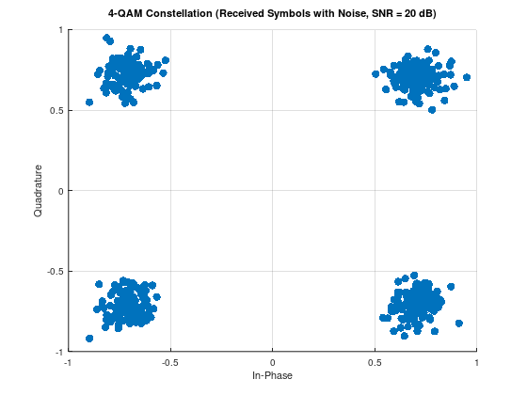
M=16
Number of bit errors: 0
Bit Error Rate (BER): 0

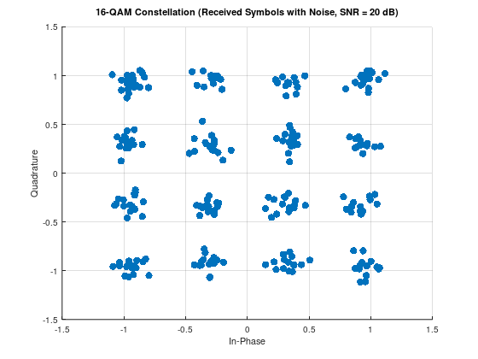

M=64
Number of bit errors: 11
Bit Error Rate (BER): 0.011044

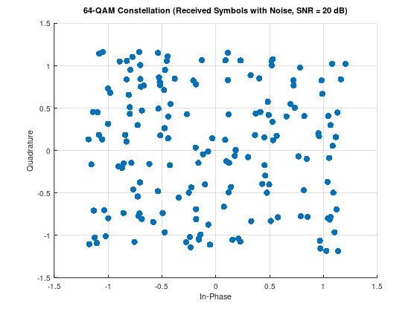

Problem 2: Adaptive Modulation and Coding (AMC) in 5G NR
Simulate an Adaptive Modulation and Coding (AMC) mechanism in 5G NR that dynamically selects modulation schemes (BPSK, QPSK, 16-QAM) based on varying SNR conditions.
- Implement SNR-based modulation adaptation.
- Evaluate BER and throughput performance for each modulation type.
- Demonstrate improved system efficiency through adaptive selection.

Program:
clc;
clear;

% Define SNR range
snr_range = 0:2:20;

% Thresholds for adaptive modulation
snr_threshold_qpsk = 5;
snr_threshold_16qam = 15;

% Initialize result storage
bits_per_symbol_all = zeros(size(snr_range));

% Loop over SNR range
for idx = 1:length(snr_range)
snr = snr_range(idx);

% Adaptive modulation selection
if snr < snr_threshold_qpsk
M = 2; % BPSK
scheme = 'BPSK';
elseif snr < snr_threshold_16qam
M = 4; % QPSK
scheme = 'QPSK';
else
M = 16; % 16-QAM
scheme = '16-QAM';
end

% Save results
bits_per_symbol = log2(M);
bits_per_symbol_all(idx) = bits_per_symbol;

% Display decision
disp(['SNR: ', num2str(snr), ' dB - Modulation: ', scheme, ' - Bits per symbol: ', num2str(bits_per_symbol)]);
end

% Plot bits per symbol vs SNR
figure;
plot(snr_range, bits_per_symbol_all, '-ob', 'LineWidth', 2, 'MarkerSize', 6);
grid on;
xlabel('SNR (dB)');
ylabel('Bits per Symbol');
title('Adaptive Modulation: Bits per Symbol vs SNR');

Result:
SNR: 0 dB - Modulation: BPSK - Bits per symbol: 1
SNR: 2 dB - Modulation: BPSK - Bits per symbol: 1
SNR: 4 dB - Modulation: BPSK - Bits per symbol: 1
SNR: 6 dB - Modulation: QPSK - Bits per symbol: 2
SNR: 8 dB - Modulation: QPSK - Bits per symbol: 2
SNR: 10 dB - Modulation: QPSK - Bits per symbol: 2
SNR: 12 dB - Modulation: QPSK - Bits per symbol: 2
SNR: 14 dB - Modulation: QPSK - Bits per symbol: 2
SNR: 16 dB - Modulation: 16-QAM - Bits per symbol: 4
SNR: 18 dB - Modulation: 16-QAM - Bits per symbol: 4
SNR: 20 dB - Modulation: 16-QAM - Bits per symbol: 4
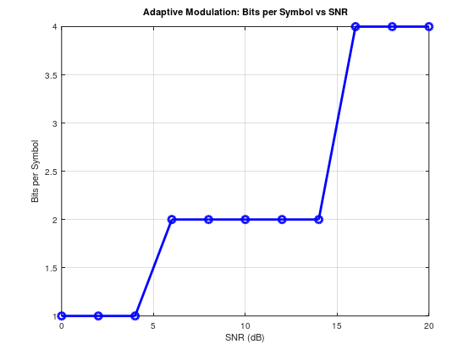

Problem 3: 5G NR Channel Coding using Parity-Check Codes
Implement basic channel coding in 5G NR using parity-check codes. Demonstrate error detection capability over an AWGN channel.
- Encode data using parity-check coding.
- Simulate transmission over an AWGN channel.
- Implement error detection and evaluate BER improvement.
Program:
clc;
clear;

% Parameters
M = 4; % QPSK
num_bits = 10000;
SNR_dB = 0:5:30;
BER = zeros(size(SNR_dB));

% Generate random bits
bits = randi([0 1], num_bits, 1);

% Manual QPSK Modulation
symbols = [];
for i = 1:2:num_bits
b1 = bits(i);
b2 = bits(i+1);
re = 2*b1 - 1;
im = 2*b2 - 1;
symbols = [symbols; (re + 1i*im)/sqrt(2)];
end

for idx = 1:length(SNR_dB)
snr = SNR_dB(idx);

% Add AWGN
noise = (randn(size(symbols)) + 1i*randn(size(symbols))) * 10^(-snr/20);
rx = symbols + noise;

% Demodulation
rx_bits = [];
for k = 1:length(rx)
re = real(rx(k));
im = imag(rx(k));
rx_bits = [rx_bits; re > 0; im > 0];
end

% BER
errors = sum(bits ~= rx_bits);
BER(idx) = errors / num_bits;
end

% Plot BER vs SNR
figure;
semilogy(SNR_dB, BER, 'bo-');
xlabel('SNR (dB)');
ylabel('BER');
title('QPSK over AWGN');
grid on;
Result:
